CMPE 362

Homework 2

Ahmet Fırat Gamsız

2020400180

Part 1:

As we increase “n” (number of coefficients) our Fourier synthesis approximates the original square wave signal better. One can easily observe the Gibbs phenomenon here. They look like horns at the end of the plateaus. This phenomenon occurs at transitions and our approximation always overshoot by 9% in the square wave case.

Part 2:

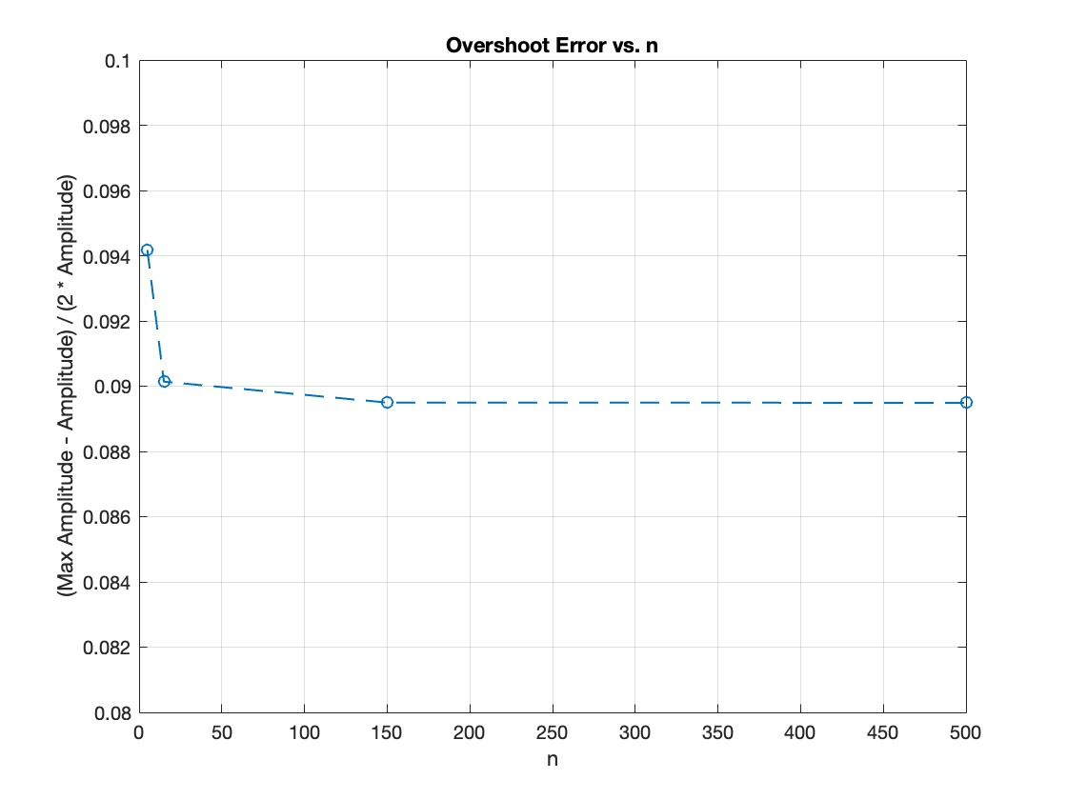

In this part (also in previous part) I used sample rate as 2*n*fundemantal_frequency + 1 to get better results (I will explain the reasoning in part 3). I calculated overshoot distance with max(square_wave) expression and used the given formula. As you can see with the increasing n, overshoot error approaches to ~0.0895.

Part 3

|  |  |  |
| --- | --- | --- |
| n | Minimum sample rate | File size |
| 5 | 1000 | 4 KB |
| 15 | 3000 | 12 KB |
| 150 | 30000 | 120 KB |
| 500 | 100000 | 400 KB |

Following the Nyquist-Shannon-Kotelnikov sampling theorem I used 2*n*fundemantal_frequency + 1 as the sampling rate. This is used to prevent the aliasing. I also increased by one because I observed, this way I was able to get closer values to theoretical value. Following the given theorem, I increased the sample rate with increasing “n”, so more points of the wave are calculated. This is the main reason of the increasing file size. One can clearly observe that from the ratio between sizes and n values. When we went from 5 to 15 the file size approximately tripled.